Note: Scanned copy of hand written text has been attached and mobile image is placed in zip folder. In case of any hazy or dark shade of scan copy image is found refer to mobile image.

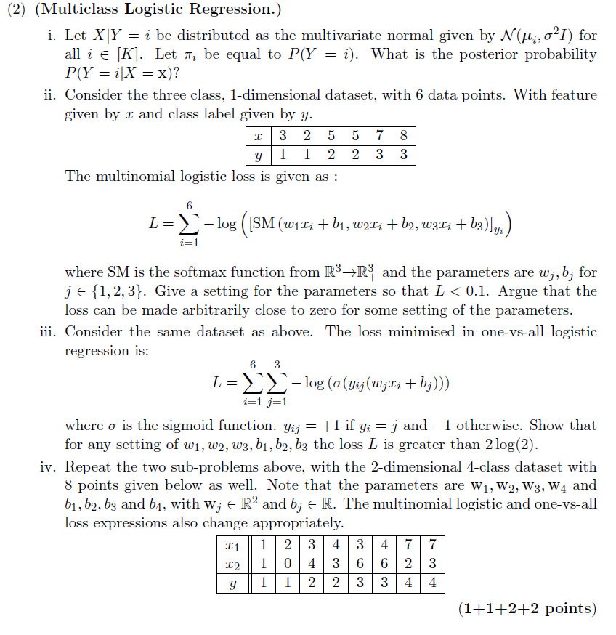

Ans.



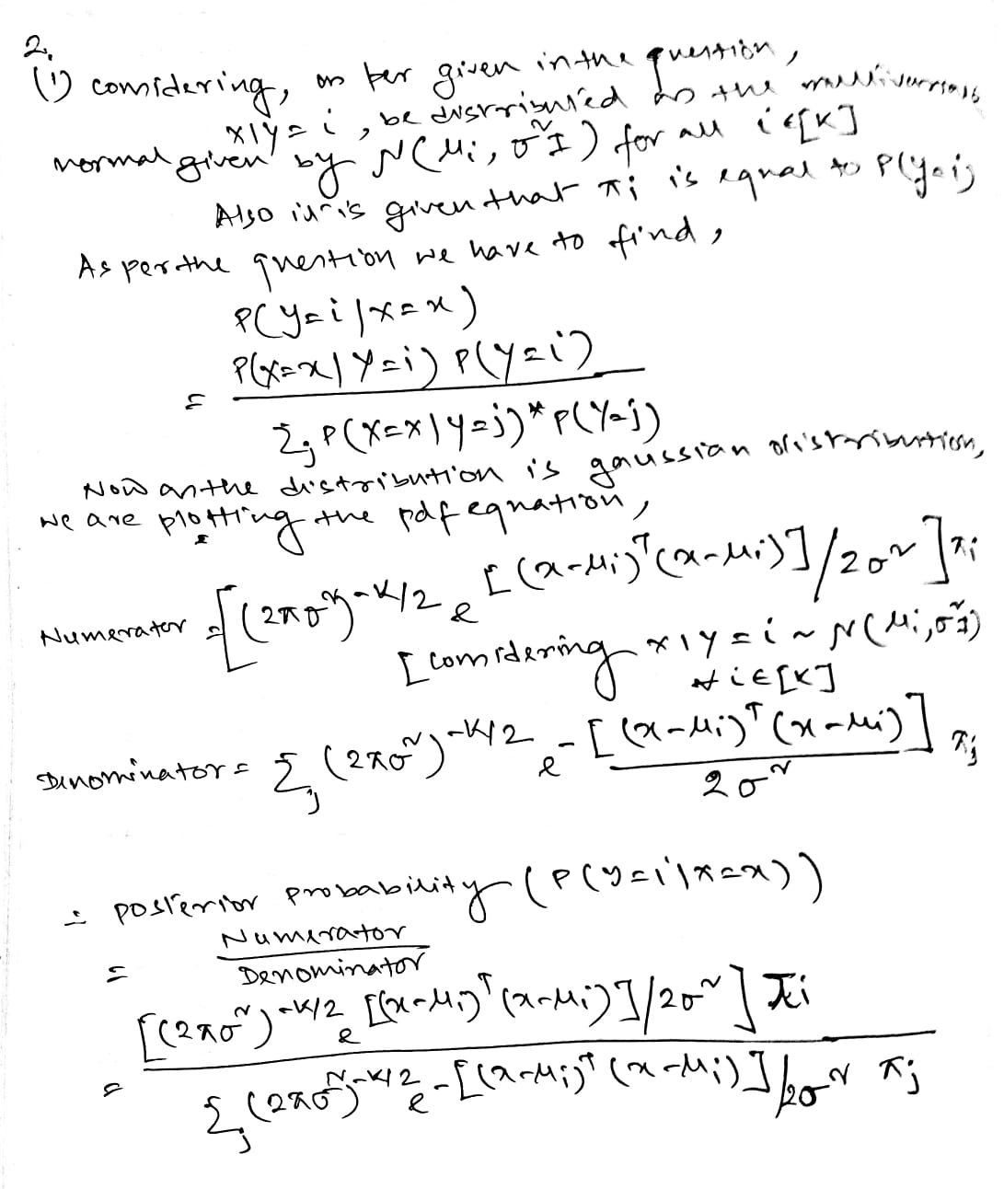

Ans.



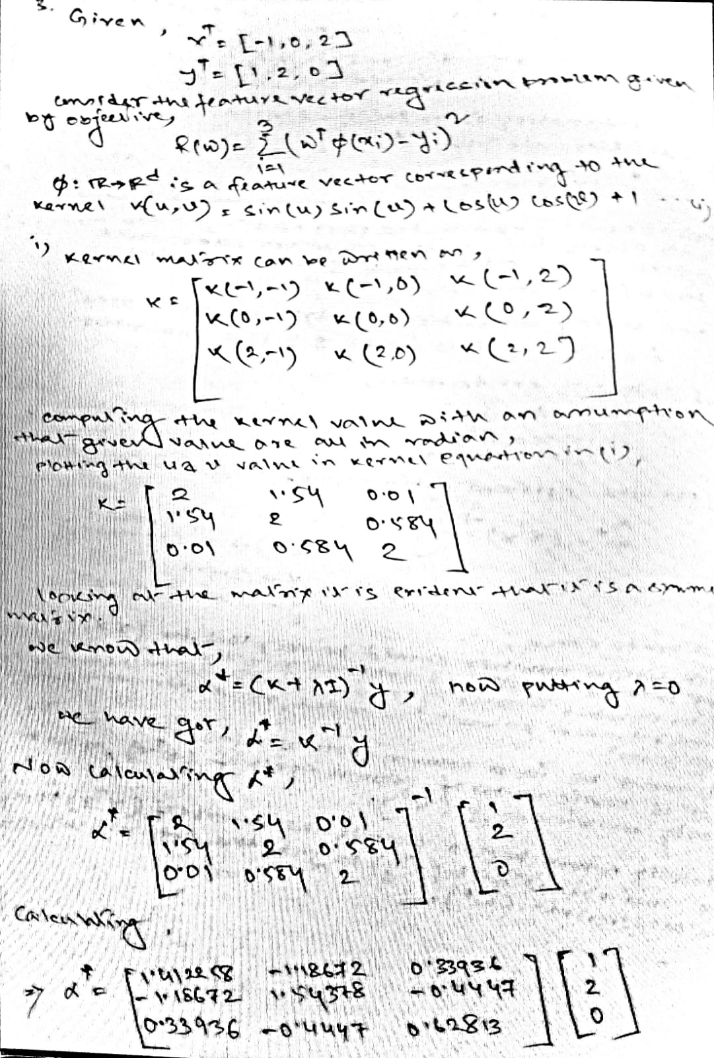

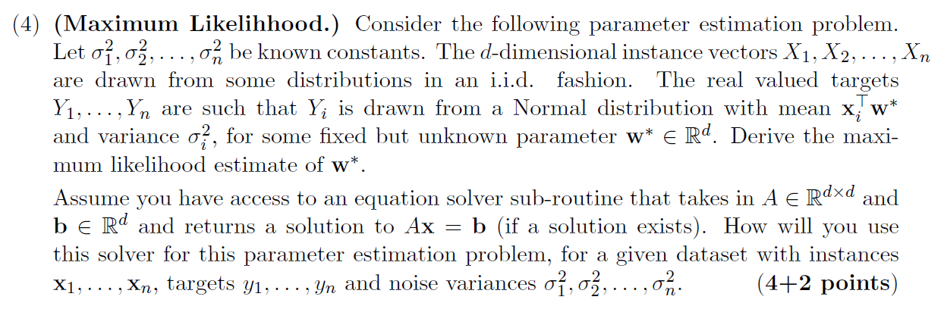

Ans.



Considering the dot product is symmetric in nature,  will yield approximately same result as . Only things to keep in mind is that the orientation of feature and datapoint will move from column to row and vice versa.

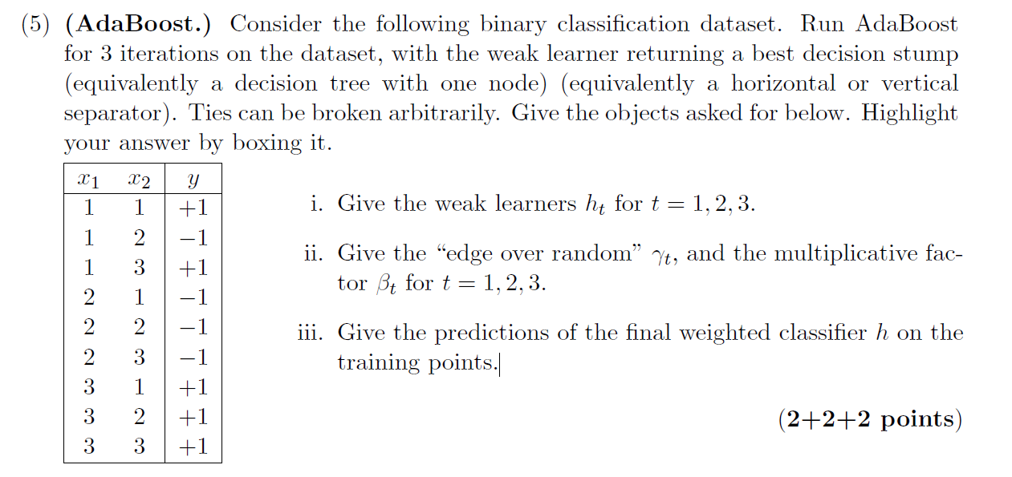

Ans.



Copying the Adaboost algorithm for reference of calculation,

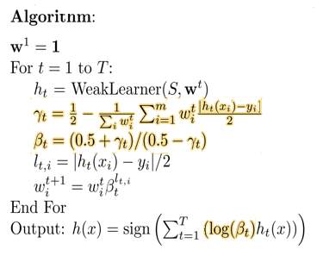

Begin the iteration for t =1, 2 and 3. Graphs are plotted, and corresponding table is shown in below,

Iteration 1:

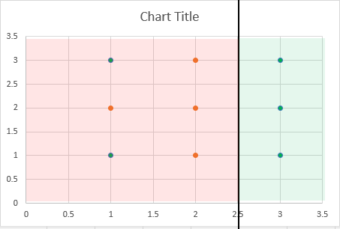

Iteration 2:

Iteration 3:

Ans.



